Task 1
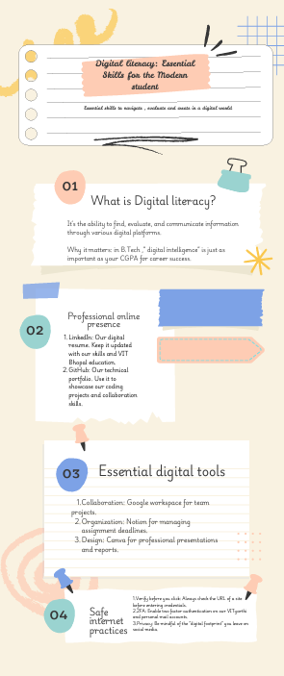

For this task, I designed a one-page visual infographic . I chose a clean, professional aesthetic using a VIT-inspired blue and white color scheme to appeal to my peers. The infographic covers four critical pillars: a foundational definition of digital literacy, a guide to building a professional presence on LinkedIn and GitHub, a list of essential academic productivity tools, and a "Safety First" section focusing on Two-Factor Authentication and phishing awareness. I used vector icons to represent each category, ensuring the resource is easy to scan quickly.
Reflection:Creating this infographic was a valuable exercise in information synthesis. The most interesting part was realizing how much "Digital Literacy" encompasses beyond just basic computer use—it’s truly about critical thinking. One thing I found slightly difficult was the "spatial constraint" of a single page; I had to decide which digital tools were most relevant to a first-year student while keeping the text concise. This forced me to prioritize quality over quantity, a skill that is essential for my role as a Student Digital Ambassador.

Task 2

1.LinkedIn
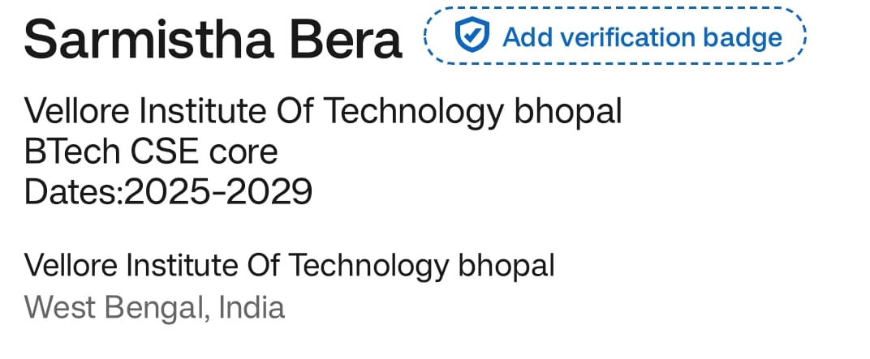

2.GitHub
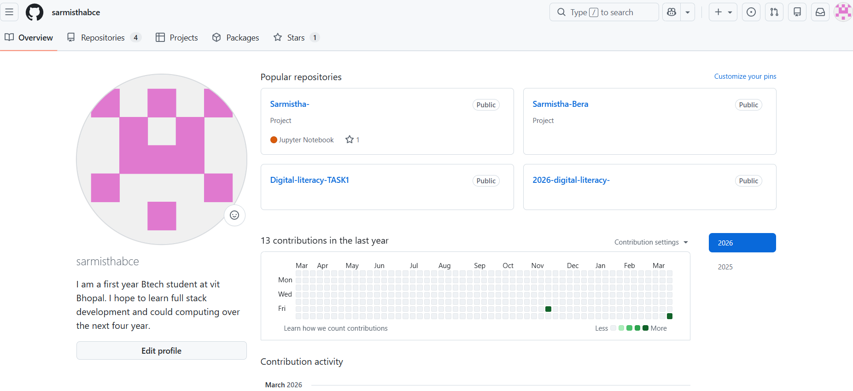

3.kaggle
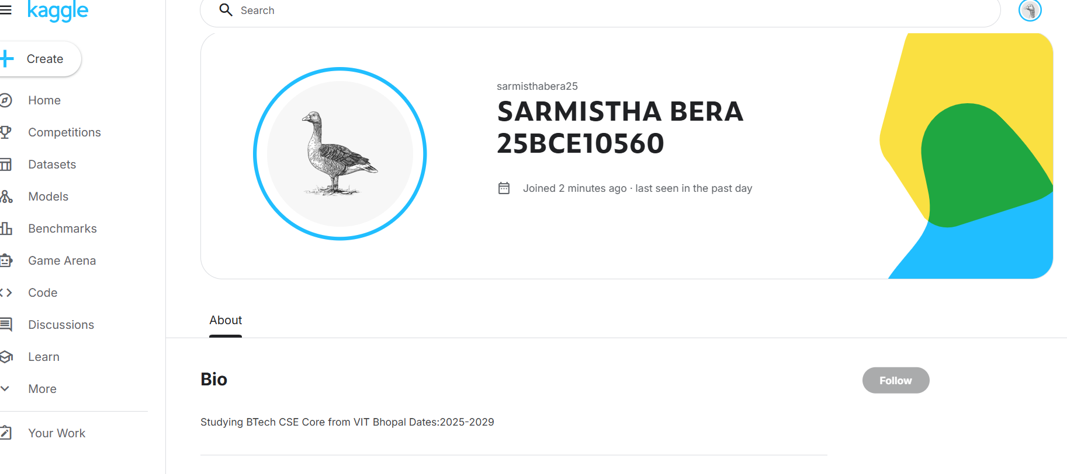

Platforms Chosen: For this task, I established my professional presence on GitHub, LinkedIn, and Kaggle.
Purpose: I chose GitHub to act as a version-controlled gallery for my coding projects. LinkedIn was selected to begin building a network with VIT alumni and industry recruiters, while Kaggle provides a platform to practice data science and compete in global challenges.
Future Plan: Over the next four years, I plan to use these platforms as a "living resume." I will commit my lab assignments to GitHub to show my coding consistency. On LinkedIn, I will document my internship experiences and certifications. On Kaggle, I aim to move from a beginner to a contributor by participating in at least two competitions per semester. This strategy will ensure that I am "industry-ready" by my final year.

Task 3

1.HackerRank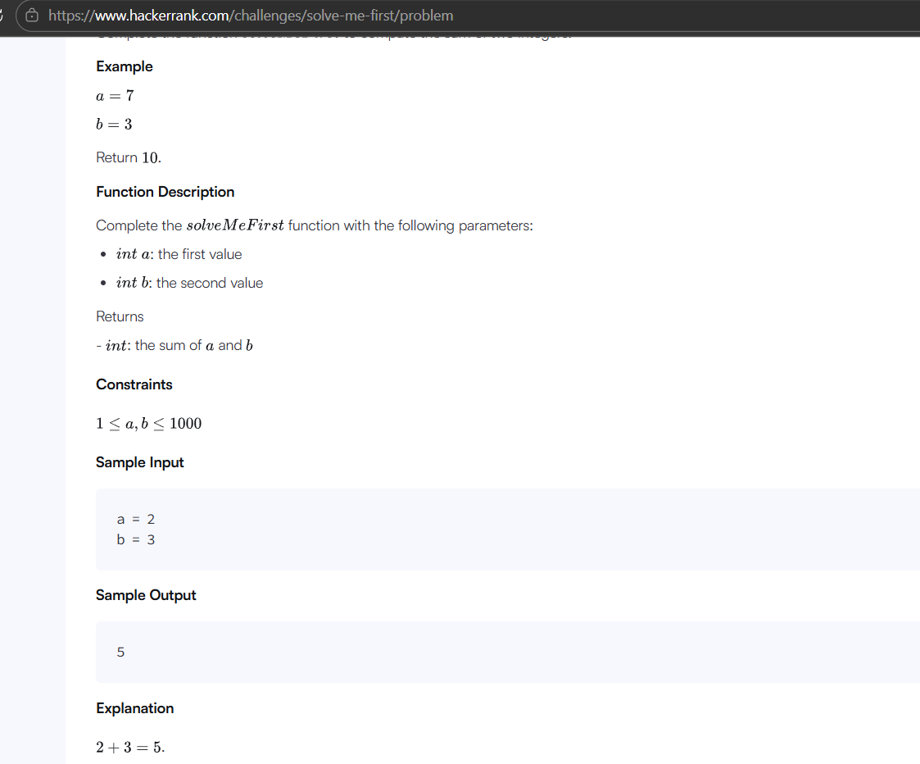

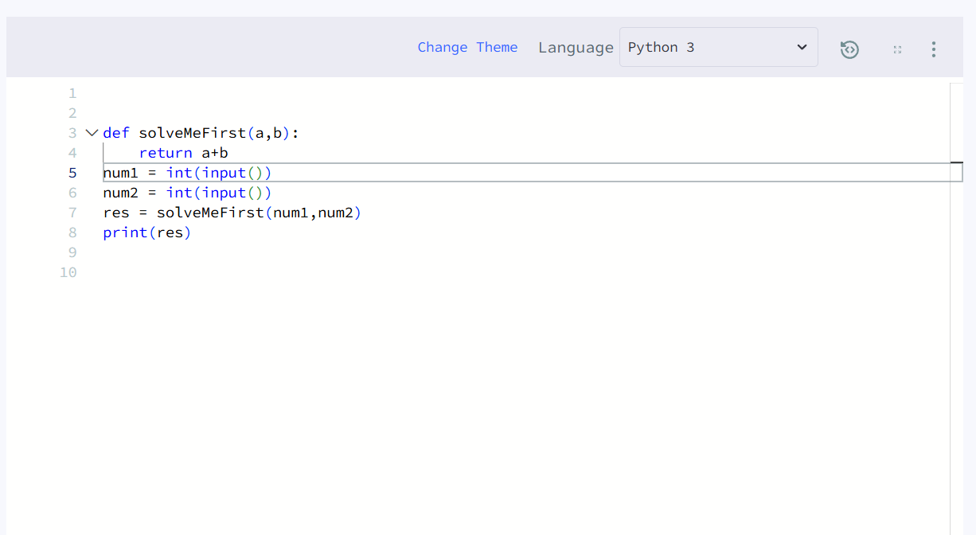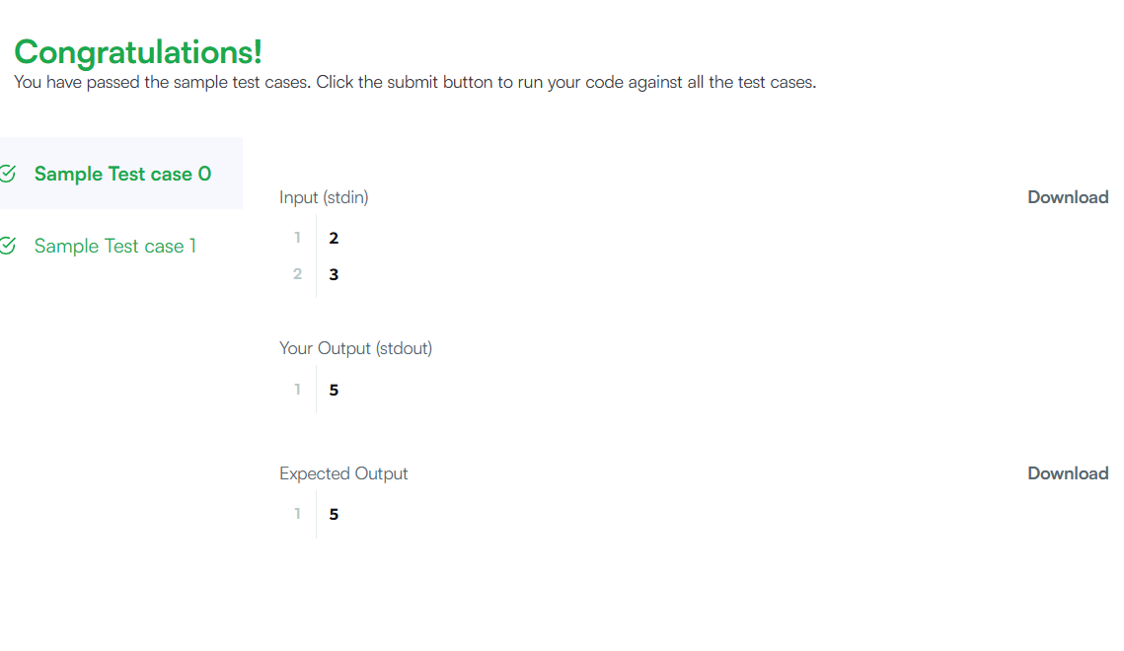

Google Form

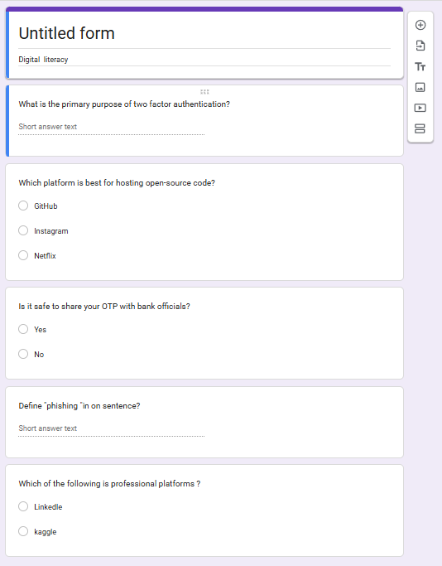

Platforms Used: For the technical portion of this task, I used HackerRank to practice algorithmic logic. For the collaboration portion, I utilized Google Forms and Google Sheets.
Activity Summary: On HackerRank, I successfully completed the [Name of Challenge] using the Python language. This helped me understand how code is evaluated against test cases. Additionally, I built a 5-question Digital Literacy Quiz using Google Forms to simulate how I would collect data and assess awareness among my peers as a Digital Ambassador.
Academic Benefit: These tools are vital for my B.Tech journey. HackerRank will help me prepare for technical interviews and improve my problem-solving speed. Google Workspace tools will allow me to collaborate effectively on team research papers and lab reports, ensuring that data is organized and accessible in the cloud. Mastering these now ensures I can focus on core engineering concepts later.

Task 4

Email 1: Requesting an Assignment Extension
Subject: Extension Request: Student of BTech CSE Core
Dear Professor [Name],
I hope this email finds you well.
I am writing to respectfully request a short extension on the deadline for the digital literacy which is currently due on 31st march 2026. Due to reason, I require an additional two days to ensure the quality of my submission meets the course standards.
I would be very grateful if you could grant me until 5th April to submit my work. Thank you for your time and consideration.
Best regards,
Sarmistha Bera
25BCEXXXXX
BTech CSE Core

Email 2: Internship Inquiry
Subject: Internship Inquiry: Summer 2026
Dear [Coordinator Name/Hiring Manager],
My name is [Your Name], and I am a first-year B.Tech student at VIT Bhopal University. I am writing to express my strong interest in a summer internship opportunity with Microsoft .
Having followed your recent work in [mention a specific project ], I am eager to apply my skills in Python contribute to your team. I have attached my resume for your review and would appreciate the chance to discuss how I can add value as an intern.
Thank you for your time and I look forward to hearing from you.
Sincerely,
Sarmistha Bera

Do’s Don’ts

Use Privacy Settings to control who sees your posts. Don't post your OTP, Boarding Pass, or Aadhaar details

Fact-check information before sharing/reposting. Don't engage in cyberbullying or "flaming" in comments.

Use a professional profile picture for LinkedIn/GitHub. Don't tag people in embarrassing photos without consent.

Keep your "About" sections updated and professional. Don't post confidential college/exam materials online.

Network with seniors and alumni politely. Don't use offensive language or "slang" in formal groups.

In our , reflect on a communication scenario:
Communication Scenario: For this task, I reflected on the importance of "Digital Tone." A common problem in digital communication is the lack of non-verbal cues, which can lead to misunderstandings. For example, a student might send a one-line email to a professor saying "Check my file," which can come across as demanding rather than a request.
Learning: By practicing these drafts, I learned that a clear subject line and a formal salutation change the entire perception of the sender. I realized that as a Digital Ambassador, teaching my peers the difference between "texting" and "emailing" is crucial for their professional success. Using a checklist for social media also helped me realize how many "small" digital habits can impact one's long-term reputation.

Task 5
Case Study: The QR Code "Payment Received" Scam
Description: This case study focuses on UPI (Unified Payments Interface) fraud, specifically the "Reverse QR Code" scam.
Scenario: A student lists an item for sale on an online marketplace. A "buyer" contacts them and claims they want to pay immediately. Instead of sending money, the scammer sends a QR code to the student via WhatsApp, claiming, "Scan this to receive the payment."
How it Happens:
1. The victim scans the QR code using a UPI app (like GPay or PhonePe).
2. The app prompts the victim to enter their UPI PIN.
3. The victim, thinking they are receiving money, enters the PIN.
4. In reality, the QR code was a "Collect Request." The moment the PIN is entered, money is deducted from the victim's account instead of being credited.
Consequences: Financial loss, emotional stress, and compromise of linked bank details. This scam targets young students and home-sellers who may be unfamiliar with how UPI request protocols work.

Prevention Checklist
Create a file named prevention-checklist.md in the task-5-cybercrime/ folder.
Stay Safe Online: Student Checklist
UPI Safety: Never enter your UPI PIN to receive money. A PIN is only required to send money.
Link Safety: Do not click on "Limited Time Offer" links sent via SMS or WhatsApp.
Public Wi-Fi: Avoid logging into bank accounts or VITyarthi using public railway or cafe Wi-Fi.
Strong Passwords: Use a mix of symbols, numbers, and cases (e.g., V!T_Bho_2026#).
Privacy: Do not share your OTP (One-Time Password) with anyone, even if they claim to be from your bank.
Software Updates: Keep your phone's OS and apps updated to patch security holes.
Identity Theft: Never share photos of your Aadhaar card or College ID on public social media.
Reporting: If scammed, immediately report it to the National Cyber Crime Portal (cybercrime.gov.in) or call the Helpline 1930.

Cybercrime Awareness Case Study & Prevention Guide
Research & Surprises:
While researching UPI fraud for this task, I was most surprised to learn how psychologically manipulative scammers can be. They often create a "sense of urgency" to stop the victim from thinking clearly. I realized that even technically-inclined students can fall victim if they don't understand the specific "Collect Request" mechanism of UPI apps. It was eye-opening to see that the National Cyber Crime Portal and the 1930 helpline are available 24/7 to assist victims in India.
Habit Change:
As a result of this research, I have decided to change my habit of using the same password across multiple platforms. I have now implemented a password manager and enabled Two-Factor Authentication (2FA) on my primary academic and financial accounts. As a Digital Ambassador, I will emphasize to my peers that "Security is a process, not a product."

